Panama Canal
Evaluating Sources
Objective | What motivated the US to build the Panama Canal?

Historical Context - Directions: Watch this video clip from the start to 4:15. Answer the questions that appear below to help you capture relevant content from the video clip.

- What were the two options to get from the Atlantic to the Pacific prior to the Panama Canal?

- What were the challenges Ferdinand De Lesseps faced while building the canal?

- Why did the US choose to build the canal in Panama and not in Nicaragua?

- Why did the US choose to support the Panamanian rebels in Colombia?

  - How did the US support the rebels once they declared independence?

- Based on this video, why do you think the US was motivated to build the Panama Canal?

  - If you wanted to confirm your claims, what kind of evidence could you research or review?

- How could President Roosevelt use the Monroe Doctrine and Roosevelt Corollary to justify the US involvement in the building of the Panama Canal?

Geographical Context - Directions: Analyze the three maps provided below and answer the analysis questions that follow each map. While looking through these maps, adopt the perspective of the following American:
- Imagine it is 1900 and you own a company that is based in New York City with customers all over the United States, including California.

Map 1: (from Wikipedia) Why would you be interested in a water route between the Atlantic and Pacific oceans? List as many possible reasons in the space below the globe. Keep in mind:
- The transcontinental railroad provides cross continental transportation, so you could connect with businesses across the US, but railroad costs are quite expensive
- Shipping by boat is cheaper than rail

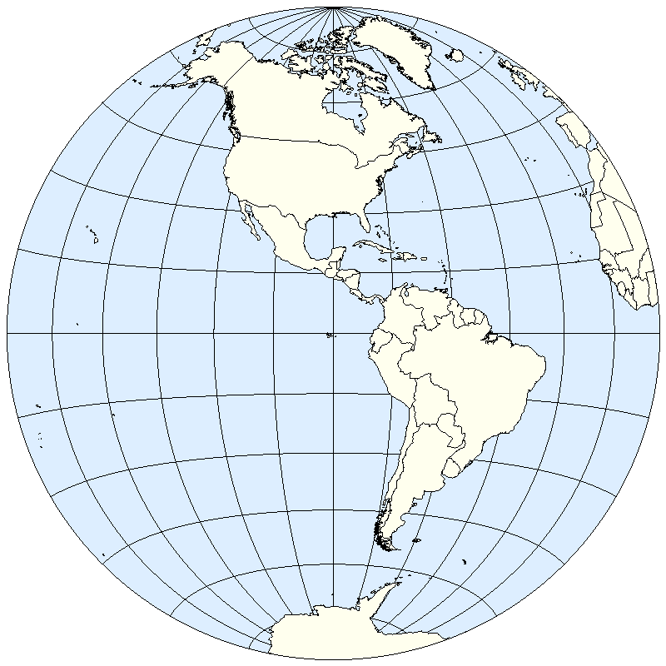
United States of America
Atlantic Ocean
Pacific Ocean
New York City

Possible reasons a business owner in the US would want a water route
connecting the Pacific and Atlantic Oceans in 1900 :

Map 2 (from google maps): Imagine you were able to ship your goods from New York to San Francisco by ship or steamboat. Where else could you send your goods to from San Francisco? (Hints below)
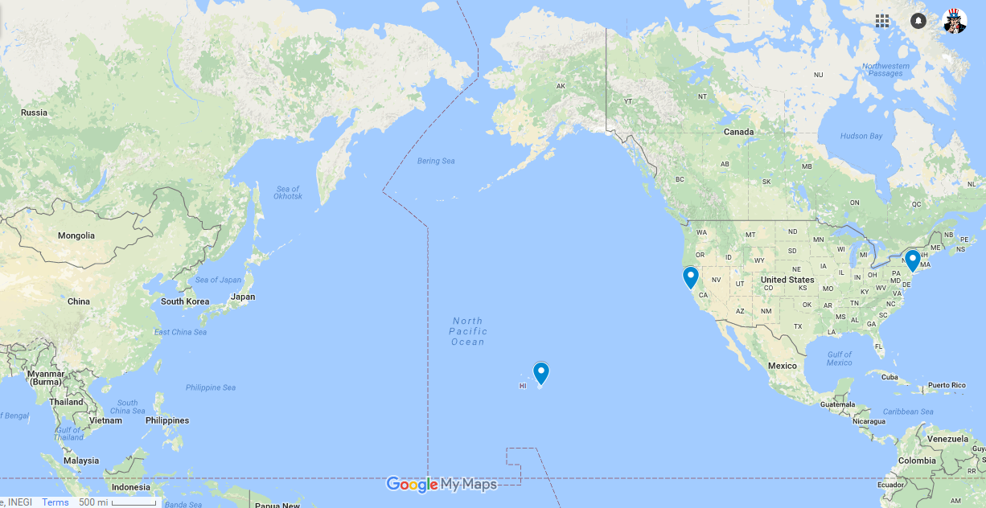
San Francisco, CA
New York, NY
Asia
Hawaii
Possible Destinations - Map 2
- Islands in the Pacific recently annexed by the United States (1898):

- Nation in Asia with which the United States had recently asserted an Open Door Policy (1899):

- Nation in Asia which the United States annexed after the Spanish-American war (1898):

Map 3 (from google maps): In the early 1900’s, President Roosevelt proposed a treaty to build and lease a canal from Panama. Based on the map below:

- If you were able to ship your goods through the Panama Canal, how many miles shorter would the shipping journey be for goods?

- Would you support this Canal? Why?

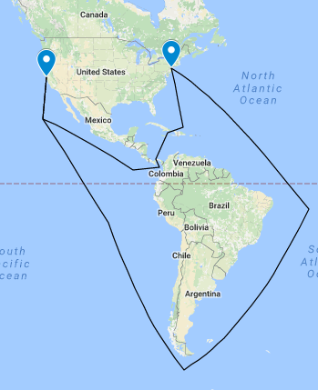
With the Panama Canal, a trade route by boat from New York to San Francisco would be 5,200 miles or 8,500 km
Without the Panama Canal, boats might have travelled around the southern end of South America, a journey that would take 13,000 miles or 21,000 km

Document Analysis: Below are two sources related to the Panama Canal. Analyze the documents by answering the questions that follow.

Document 1: Influence of Sea Power Upon History by Alfred Thayer Mahan (1890)

The history of Sea Power is largely, though by no means solely, a narrative of contests between nations, of mutual rivalries, of violence frequently culminating in war…

In these three things - production, with the necessity of exchanging products, shipping, whereby the exchange is carried on and colonies, which facilitate and enlarge the operations of shipping and tend to protect it by multiplying points of safety - is to be found the key to much of the history, as well as of the policy of nations bordering upon the sea…

If one (a central American canal) be made, and fulfill the hopes of its builders, the Caribbean will be changed from a terminus, and place of local traffic, or a best a broken and imperfect line of travel as it now is, into one of the great highways of the world. Along this path great commerce will travel, bringing the interests of the other great nations, the European nations, close along our shores, as they have never been before …

Furthermore, as her distance from the Isthmus, though relatively less, is still considerable, the United States will have to obtain in the Caribbean stations fit for contingent, or secondary, bases of operations; which by their natural advantages, susceptibility of defence, and nearness to the central strategic issue, will enable her fleets to remain as near the scene as any opponent …

....we can live off ourselves indefinitely in 'our little corner,' to use the expression of a French officer to the author. Yet should that little corner be invaded by a new commercial route through the Isthmus, the United States in her turn may have the rude awakening of those who have abandoned their share in the common birthright of all people, the sea …

The government by its policy can favor the natural growth of a people's industries and its tendencies to seek adventure and gain by way of the sea . . . The influence of the government will be felt in its most legitimate manner in maintaining an armed navy, of a size commensurate with the growth of its shipping and the importance of the interests connected with it.

Document 1 - Analysis Questions:

- Sourcing: Alfred Mahan was a US Navy Commander and a naval historian. How might his perspective have impacted this source?

- Sourcing: The intended audience of this source was the State Department and other government officials who shaped foreign policy. Alfred Mahan wrote this book to argue that naval supremacy determined a nation’s power. How might the intended audience and purpose have shaped his writing?

  - Sourcing: Knowing more about his intended audience and purpose - how does this shape or impact your reading of this source?

- Sourcing: Was this source written before or after the construction of the Panama Canal? How might this source have impacted or shaped the thoughts of leaders such as President Theodore Roosevelt who eventually built the Panama Canal?

- Close Reading: According to Mahan, why should the US pursue the construction of a canal in Central America?

- Close Reading: According to Mahan, why should a nation pursue sea power?

- Close Reading: Does Mahan provide evidence for his claims?

Document 2: The San Francisco Call Daily News: August 14, 1912, Image 9 | Original source here

Crossroads of Pacific Ready
By Elmer E. Paxton

The Panama Canal - the severance of two great continents and the union of two mighty oceans whose shores mark the world’s greatest empires - will soon be a reality. American history will justly claim this work as the greatest engineering achievement of modern times, to endure for all the ages. Although built primarily for the national defense, in the years to come it may be a highway of universal peace, through which an international commerce will be developed, binding the nations of the east and west together in a strength of commercial amity hitherto impossible and unknown.  It has often been said that the Pacific ocean, with it shores and islands, will be the future theater of the world’s greatest commercial activity. The possibilities of awakened China, the growing world power of Japan, the vast undeveloped resources of Western America, in conjunction with the opening of the great waterway, certainly point to an ocean commerce of colossal proportions in comparison with present day traffic.  Four thousand six hundred miles westward from Panama lie the Hawaiian islands, the “Crossroads of the Pacific” and America’s greatest future naval base. These islands are unique in their location with relation to ocean routes, in their climatic and scenic attractions and in their natural resources, considering limited area and population. The opening of the canal is therefore a matter of the keenest interest to everyone in Hawaii who has a feeling of patriotic pride in great national achievements, who realize the important part these islands will play in the national defenses, and who looks forward to the great commercial and material benefits which will accrue to the territory under the vastly improved transportation facilities. | The importance to the Navy  The importance of the island of Oahu as a great fortified naval base will be greatly increased by the opening of the canal. Admiral Cowles, commandant, naval station, Hawaii, sums up the situation as follows: “The importance of Honolulu as a naval base has been so well recognized by those in authority as is shown in the liberal spending which has been granted by Congress for the development of this station, that it is not necessary to say any more on the subject except in so far as the strategic position of Honolulu is affected by the opening of the Panama Canal.  Its situation will then be not far from the line of communication between the Canal and China and Japan. One of our fleets coming out from the Atlantic through the canal for operations in the Pacific would probably make its first stop here for final preparations. The stock of coal, ammunition, and supplies of all kinds would therefore be kept at the maximum, as whether going or returning, the fleet would naturally make this station its principal resort for replenishing or for repair. It would also furnish a rendezvous for commerce destroyers and submarines. It also offers great opportunities for a rendezvous for reinforcement so that personnel of a fleet engaged in Chinese waters, that is a rendezvous most convenient and secure. It may also be noted that with strong defensive batteries a fleet or its component parts could not be well confined in port, as opportunities for its escape from a blockading fleet would be excellent...In fact, almost in proportion as the opening of the canal would increase the efficiency of the fleet it would increase the importance of Honolulu as a naval base….”

Document 2 - Analysis Questions:

- Sourcing: Is this a primary source or secondary source?

  - Sourcing: Is this a scholarly article or a newspaper article?

    - Sourcing: What does that suggest to you about the purpose or audience of this source? How does this shape your reading of this article?

- Analysis: Does the author provide any specific evidence for his various claims?

- Close Reading: According to the first paragraph, why was this canal originally built?

- Close Reading: What does “It has often been said that the Pacific ocean, with its shores and islands, will be the future theater of the world’s greatest commercial activity. The possibilities of awakened China, the growing world power of Japan, the vast undeveloped resources of Western America, in conjunction with the opening of the great waterway….” tell you about a secondary motivation to build the Panama Canal?

- Close Reading: According to the article, which organization responsible for US defense will benefit the most: the army, navy, or airforce?

  - Close Reading: Why will this entity of US defense benefit from the canal? Cite at least two reasons mentioned in the article.

Panama Canal
Evaluating Sources
Written Task | What motivated the US to build the Panama Canal?

Task - Using the documents above, and your knowledge of US History, please complete the following:

Answer each of the questions below in one paragraph each.

Contextualization: According to the two primary source documents above, what was one political, and one economic reason for building the Panama Canal?

Analysis / Sourcing: What were some potential biases you kept in mind when reading both sources?

