Hamilton vs Jefferson
Evaluating Sources
Objective | To what extent does Hamilton the musical accurately depict the debate between Hamilton and Jefferson over the National Bank of the United States?

Directions: Review the chart below carefully and use it to answer the analysis question below.

Issues | Hamilton  (Federalist Party) | Jefferson  (Democratic-Republican Party)
Federalism (division of power) | Strong central government, weak state governments | Strong state governments, weak central government
Tariff (taxes) on imported goods | US government should tax imported goods to generate revenue and pay off debts. This encourages people to buy American made goods and encourages manufacturing. | States should not be subjected to a national tax of any kind. There should be no tariffs on imports.
US Economy | Manufacturing, the US government should support manufacturing | Farming is the main economic activity that the US should protect and support
Interpretation of the Constitution | Elastic clause allows for loose interpretation of the Constitution | Strict interpretation, government shouldn’t go beyond what is outlined in Constitution
Whiskey Rebellion | National government has the power to issue taxes to raise revenue. The Whiskey Rebellion represents a plot to promote states rights and was put down properly. | National government should leave taxation to the states. In the Whiskey Rebellion, the government used the army to put down legitimate protest to an unfair government tax.

Analysis Question: Based on the information in this chart, predict what Hamilton and Jefferson would do in the following scenario:

There is a proposal to create a National Bank of the United States. The power to create this bank is not explicitly listed in the US Constitution, but those who support it cite the elastic clause (which suggests that congress can do anything necessary and proper for the functioning of our nation) as a reason why this bank would be constitutional. Those who oppose it believe it is an expansion of Federal power therefore dangerous.

- Who do you think would support the bank - Hamilton or Jefferson and why?

- Who do you think would be against the bank - Hamilton or Jefferson and why?
Historical Context - Cabinet Battle #1 from Hamilton (2015) - a Broadway Musical
In July 2008, while Lin-Manuel Miranda was on vacation in Mexico, Lin-Manuel took on a little light reading in the form of Ron Chernow’s 800-page New York Times best-selling biography, Alexander Hamilton, chronicling the life of the first Treasury Secretary of the United States. Lin-Manuel was captivated by the story of Hamilton’s life and how the very human struggles of the American Revolution continue to manifest themselves in today's society. From here, an idea grew to tell the story of Hamilton through contemporary song stylings, but the shape of that project was still a long way from being fully-formed. At the time, it was conceived as a concept album to be known as "The Hamilton Mixtape." Eventually, this became Hamilton, a broadway musical that debuted in New York City in 2015.

Directions
One song from the second act of the musical, Cabinet Battle # 1, reviews the debate between Thomas Jefferson and Alexander Hamilton over the creation of the National Bank. Listen to the song twice, using the prompts below to guide you. When you are done, compare the lyrics of the song to the primary source documents provided to evaluate the songs as a source of historical documentation.

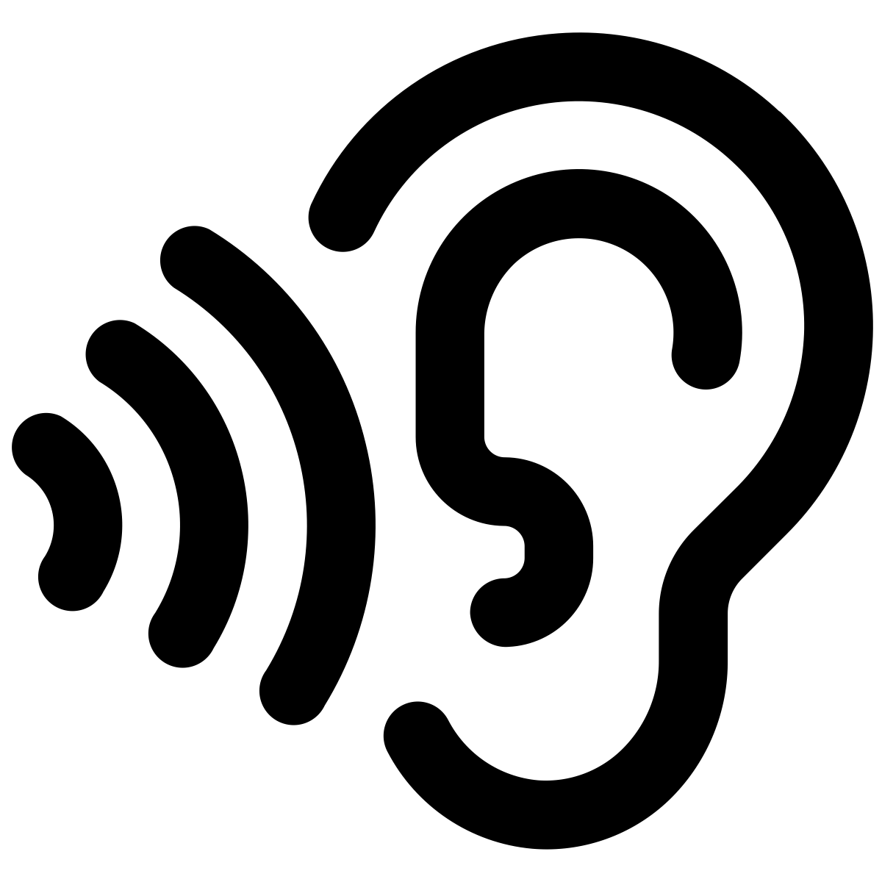
First Listen: Cabinet Battle # 1: Listen to the song Cabinet Battle #1 from Hamilton the Musical by Lin Manuel-Miranda (2015). The first time you listen to it, jot your thoughts down in the box below. Use the questions below to help you shape your notes and reflections.

- What do you hear?
- Based on this song, who do you think supports the bank?
- Based on your first listen to this song, what do you think the relationship was like between Hamilton and Jefferson?

Second Listen: Cabinet Battle # 1: Listen to the song Cabinet Battle #1 from Hamilton the Musical by Lin Manuel-Miranda (2015). In the table below are the lyrics on the left with annotations on the right. Read both and follow along with the song. When you are done listening and reading, answer the analysis questions that appear after the lyrics and annotations.

Lyrics | Annotations  (note these were made with the help of rap genius)
[WASHINGTON]  Ladies and gentlemen, you coulda been anywhere in the world tonight, but you’re here with us in New York City. Are you ready for a cabinet meeting???¹  The issue on the table: Secretary Hamilton’s plan to assume state debt and establish a national bank². Secretary Jefferson, you have the floor, sir  [JEFFERSON]  ‘Life, liberty and the pursuit of happiness.’  We fought for these ideals; we shouldn’t settle for less  These are wise words, enterprising men quote ‘em  Don’t act surprised, you guys, cuz I wrote ‘em³  [JEFFERSON/ JAMES MADISON]  Oww  [JEFFERSON]  But Hamilton forgets  His plan would have the government assume state’s debts  Now, place your bets as to who that benefits:  The very seat of government where Hamilton sits⁴  [HAMILTON]  Not true!  [JEFFERSON]  Ooh, if the shoe fits, wear it  If New York’s in debt—  Why should Virginia bear it? Uh! Our debts are paid, I’m afraid  Don’t tax the South cuz we got it made in the shade  In Virginia, we plant seeds in the ground  We create. You just wanna move our money around⁵  This financial plan is an outrageous demand  And it’s too many damn pages for any man to understand⁶  Stand with me in the land of the free  And pray to God we never see Hamilton’s candidacy  Look, when Britain taxed our tea, we got frisky  Imagine what gon’ happen when you try to tax our whisky  [CROWD (reacting)] That's my alcohol! [HAMILTON] Thomas. That was a real nice declaration Welcome to the present, we’re running a real nation Would you like to join us, or stay mellow Doin’ whatever the hell it is you do in Monticello? If we assume the debts, the union gets A new line of credit, a financial diuretic How do you not get it? If we’re aggressive and competitive The union gets a boost. You’d rather give it a sedative?⁷ A civics lesson from a slaver. Hey neighbor Your debts are paid cuz you don’t pay for labor “We plant seeds in the South. We create.” Yeah, keep ranting We know who’s really doing the planting⁸ And another thing, Mr. Age of Enlightenment Don’t lecture me about the war, you didn’t fight in it You think I’m frightened of you, man? We almost died in the trench While you were off getting high with the French Thomas Jefferson, always hesitant with the President Reticent—there isn’t a plan he doesn’t jettison Madison, you’re mad as a hatter, son, take your medicine Damn, you’re in worse shape than the national debt is in⁹ Sittin’ there useless Hey, turn around, bend over, I’ll show you Where my shoe fits [WASHINGTON] Thank you, Secretary Jefferson  [WASHINGTON]  Excuse me? Madison, Jefferson, take a walk! Hamilton, take a walk! We’ll reconvene after a brief recess. Hamilton!  [HAMILTON]  Sir!  [WASHINGTON]  A word  [MADISON]  You don’t have the votes  [JEFFERSON/MADISON]  You don’t have the votes  [JEFFERSON]  Aha-ha-ha ha!  [JEFFERSON/MADISON]  You’re gonna need congressional approval and you don’t have the votes  [JEFFERSON]  Such a blunder sometimes it makes me wonder why I even bring the thunder  [MADISON]  Why he even brings the thunder…  [WASHINGTON]  You wanna pull yourself together?  [HAMILTON]  I’m sorry, these Virginians are birds of a feather  [WASHINGTON]  Young man, I’m from Virginia, so watch your mouth  [HAMILTON]  So we let Congress get held hostage by the South?  [WASHINGTON]  You need the votes  [HAMILTON]  No, we need bold strokes. We need this plan  [WASHINGTON]  No, you need to convince more folks  [HAMILTON]  James Madison won’t talk to me, that’s a nonstarter  [WASHINGTON]  Winning was easy, young man. Governing’s harder¹⁰  [HAMILTON]  They’re being intransigent  [WASHINGTON]  You have to find a compromise  [HAMILTON]  But they don’t have a plan, they just hate mine!  [WASHINGTON]  Convince them otherwise  [HAMILTON]  What happens if I don’t get congressional approval?  [WASHINGTON]  I imagine they’ll call for your removal  [HAMILTON]  Sir—  [WASHINGTON]  Figure it out, Alexander. That’s an order from your commander | 1: President George Washington’s Cabinet was the first such group of presidential advisors. Thomas Jefferson was the Cabinet Secretary of State (foreign affairs) and Alexander Hamilton was the Secretary of Treasury  2: In his capacity as Secretary of Treasury, Hamilton proposed a plan to create a National Bank  3: Jefferson is referring to the fact that he wrote the Declaration of Independence here; it was not widely known that he was the author at the time.  4: Hamilton argued that having the federal government assume state debts would bind them together and strengthen the power of the federal government. Jefferson also implies that Hamilton’s support of it is self-serving. Making the federal government responsible for more of the nation’s financial future would specifically vest more power in the Department of Treasury, the department Hamilton was head of.  5: Jefferson is basically saying that a state’s debt should be its own responsibility to pay off—no state should be responsible for another’s failings. Some states like Virginia, Maryland, and Georgia had paid off their war debts, partially by levying high taxes.  6: Here the lyrics of Jefferson are also alluding to the idea that Federalists tended to believe in elitism and that men like themselves (learned, educated, and mostly wealthy men) should be the ones who govern, whereas the Democratic-Republicans tended to believe in the ideas of the Anti-Federalists, that the government should be run by ordinary men.  7: In these lyrics, Hamilton is suggesting that assuming the debts of the nation and creating a new line of credit through the National Bank would jumpstart the economy.  8: In the earlier verse Jefferson suggested that as farmers in Virginia, they are contributing to the economy in the most important way. Here Hamilton is calling out Jefferson as a hypocrite by alluding to the fact that slaves were the ones who did the planting.  9: Madison, a Democratic-Republican, and eventually the 4th President of the US, was rumored to have many different ailments, including hypochondria (irrational fear of diseases), and epilepsy (a disorder where one would have frequent seizures).  10: Through this back and forth, we learn the Bank wasn’t a popular idea. During the Revolutionary War, Hamilton served as Washington’s secretary. Here, President Washington is saying to Hamilton that winning the war seems easy in comparison to the harder task of actually governing the nation.
Analysis Questions:

- Sourcing: Is this song a secondary source or a primary source?

- Sourcing: Do you trust this source? Do you think it is reliable? Why or why not?

- Close Reading: Identify the claims made by the song as to why Jefferson DID NOT support the Bank of the United States. Use evidence from the lyrics to support your claims.

- Close Reading: Identify the claims made by the song as to why Hamilton DID support the Bank of the United States. Use evidence from the lyrics to support your claims.

- Corroboration: What other types of documents would you have to consult to verify if this song is accurate in explaining the debate between Hamilton and Jefferson over the proposed National Bank?

Corroboration: Read the excerpts of the two sources below, and answer the analysis questions that follow.

Source #1: Jefferson's Opinion on the Constitutionality of the National Bank (1791)
...I consider the foundation of the Constitution as laid on this ground in the tenth amendment: That "all powers not delegated to the United States, by the Constitution, nor prohibited by it to the States, are reserved to the States or to the people." To take a single step beyond the boundaries thus specially drawn around the powers of Congress, is to take possession of a boundless field of power, no longer susceptible of any definition...The incorporation of a bank, and the powers assumed by this bill, have not, in my opinion, been delegated to the United States, by the Constitution.

… In article one section eight of the US Constitution, it reads that the legislative body (congress) shall have the power to "regulate commerce with foreign nations, and among the States, and with the Indian tribes." To erect a bank, and to regulate commerce, are very different acts….

The second general phrase quoted in support of the Constitutionality of this bank is the necessary and proper clause that, "to make all laws necessary and proper for carrying into execution the enumerated (listed) powers." But they can all be carried into execution without a bank. A bank therefore is not necessary, and consequently not authorized by this phrase…. Congress with power to do whatever would be for the good of the United States; and, as they would be the sole judges of the good or evil, it would be also a power to do whatever evil they please...

Source #2: Hamilton's Opinion on the Constitutionality of the National Bank (1791)
….The bank does have constitutional basis when closely examining the commerce powers as outlined in the Constitution...The proposed bank is to consist of an association of persons, for purpose of creating a join capital, to be employed, chiefly, and essentially, in loans....the bank as it proposed will be the receiver of all taxes collected...accordingly it is affirmed that the bank has a relation, more or less direct, to the power of collecting taxes; to that of borrowing and lending money; to that of regulating trade between the states, all of which are outlined as powers of Congress in article one of the US Constitution.

And in the last place, it will be argued, that it is clearly within the provision which authorizes the making of all needed rules and regulations concerning the property of the United States…. The only question must be in this, as in every other case, whether the mean to be employed or in this instance, the corporation to be erected, has a natural relation to any of the acknowledged objects or lawful ends of the government. Thus a corporation may not be erected by Congress for superintending the police of the city of Philadelphia, because they are not authorized to regulate the police of that city. But one may be erected in relation to the collection of taxes, or to the trade with foreign countries, or to the trade between the States, or with the Indian tribes; because it is the province of the federal government to regulate those objects, and because it is incident to a general sovereign or legislative power to regulate a thing, to employ all the means which relate to its regulation to the best and greatest advantage. . . .

Analysis Questions:

- Sourcing: Are sources #1 and 2 secondary sources or primary sources? How do you know?

- Sourcing: Do you trust source #1 and #2? Do you think they are reliable? Why or why not?

- Close Reading: In source #1, Thomas Jefferson makes three claims regarding why he believes the National Bank of the United States would be unconstitutional. What are these three claims?

- Close Reading: How do the reasons outlined in source #1 compare with Jefferson’s lyrics in Cabinet Battle #1? Does the song seem to accurately represent Jefferson’s reasons for opposing the bank? Cite evidence from both source #1 and the song to support your claim.

- Close Reading: In source #2, Alexander Hamilton makes two claims regarding why he believes the National Bank of the United States would be Constitutional. What are these two claims?

- Close Reading: How do the reasons outlined in source #2 compare with Hamilton’s lyrics in Cabinet Battle #1? Does the song seem to accurately represent Hamilton’s reasons for supporting the bank? Cite evidence from both source #2 and the song to support your claim.

Hamilton vs. Jefferson
Evaluating Sources
Written  Task | To what extent does Hamilton the musical accurately depict the debate between Hamilton and Jefferson over the National Bank of the United States?

Directions: Using information from the document above, please respond to the following writing task.

Task: Using the information from the document above, and your knowledge of US History complete the following writing prompt:

To what extent does Hamilton the musical accurately depict the debate between Hamilton and Jefferson over the National Bank of the United States?
- Specifically, how does the song Cabinet Battle # 1 depict the debate between Hamilton and Jefferson? To what extent do you think the song is accurate?
  - Cite evidence from the lyrics of the song, source #1 (Jefferson’s Opinion - 1791), and source # 2 (Hamilton’s opinion - 1791) to support your claims.

