Document 1 “Lands Ceded by Mexico,” Historical Atlas of U.S. History, 1996
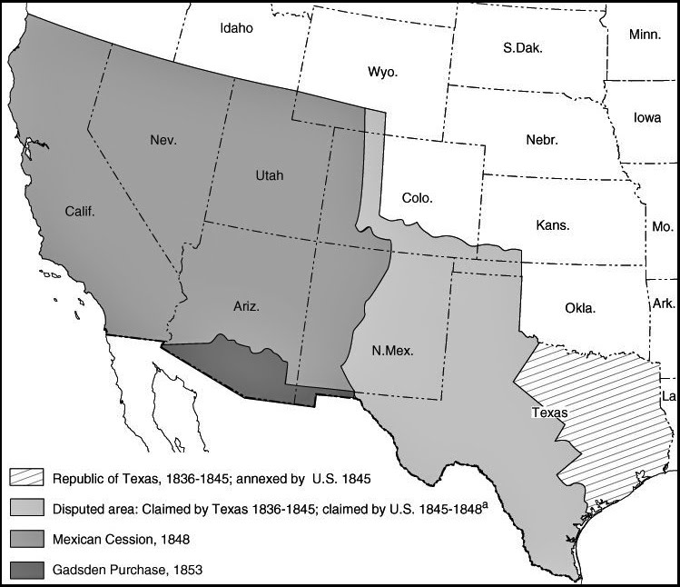

Document 2: Secretary of State Abel Upshur, Letter to Diplomat W.S. Murphy, 1843
“The establishment, in the very midst of our slave-holding States, of an independent Government, forbidding the existence of slavery, and by a people born for the most part among us, reared up in our habits, and spreading our language, could not fail to produce the most unhappy effects upon both parties. If Texas had been in that condition [a free territory], her territory would become a ready refuge for the fugitive slaves of Louisiana and Arkansas... Few calamities would have been more deplored than the establishment of a British influence in Texas, and the abolition of domestic slavery in Texas.”

Document 3: James Buchanon (future president) on the annexation of Texas, 1844
It is highly probable that the question for the admission of Texas into the Union may force itself upon the consideration of congress...In my judgment it would be far better for this country that Texas should remain an independent State if this were possible. But suppose that this cannot be, & then we must either admit it to the Union or see it pass under the dominion of Great Britain; --what ought then to be done?...Can any evils which might result from Texas’ admission be equal to those which would most probably result from having Great Britain our neighbour along our Southwestern frontier?

Document 4: Letter from Andrew Jackson to Moses Dawson, published in Niles’ National Register, 1844.
If there be patriotism in the effort to increase the wealth and happiness of all classes in our society—to diffuse the blessings of equal laws, and a just government . . . if there be love in the spirit which finds in this free land of ours the means to spread the light of the Gospel, and to teach fallen man throughout the world how he may recover his right to civil and religious liberty—it seems to me that all this patriotism—all this philanthropy—all this religion—appeals to us in favor of the addition of Texas to our Union.

Document 5: Anti-Texas Petition, 1838 and Anti-war Speech, 1847
The Mexican-American War gave rise to the first truly national anti-war movement and divided the country between those who supported the war and those who opposed it. Many anti-war groups held protests and made speeches to voice their opposition to the annexation of Texas and the war with Mexico.
“No man regards this war as just...This war is waged against an innocent people...for the purposes of conquest and with the ambition [desire] to extend slavery…this territory has been wrested from Mexico by violence and fraud...the ultimate result will be 18 or 20 more slaveholders in the Senate…”

Document 6: Henry Clay, Letter to editors of the National Intelligencer, April 17, 1844
I know there are those who regard a war with Mexico as a trifling affair, on account of the weakness of Mexico, and her inability in inflict serious injury upon this country. But I regard all wars as great calamities, to be avoided, if possible. . . I do not think that Texas ought to be received into the Union . . . it is in opposition to the wishes of a considerable and respectable portion of [the United States]. I think it far more wise and important to harmonize the present union, as it now exists, than to introduce a new element of discord and distraction into it . . . No motive for the acquisition of foreign territory would be more unfortunate than that of obtaining it for the purpose of strengthening one part against another part of the [country], which would . . . certainly sow the seeds of a dissolution of the Union . . . In addition, It is estimated that Texas has a debt of $10,000,000 - if we are absorb Texas, we are to absorb that debt, which we can not afford...”
Document 7: The Proposed Annexation of Texas, 1845
In 1845, while the annexation of Texas was still being debated, some Congressmen proposed splitting Texas in two or more states, with some being free and some being slave. Opponents argued that this would greatly increase the power of slaveholding states by adding one or more large slave states. Below is a broadside made to oppose annexation.

