Document 3A: The Wilmot Proviso
Just a few months into the war, Pennsylvania Congressman David Wilmot proposed that slavery be banned in any territory gained from the war. It passed the House but was repeatedly defeated in the Senate, where the South was dominant. The top map shows what would have occurred under the Proviso. The bottom map shows the actual state of the free and slave states in 1846.

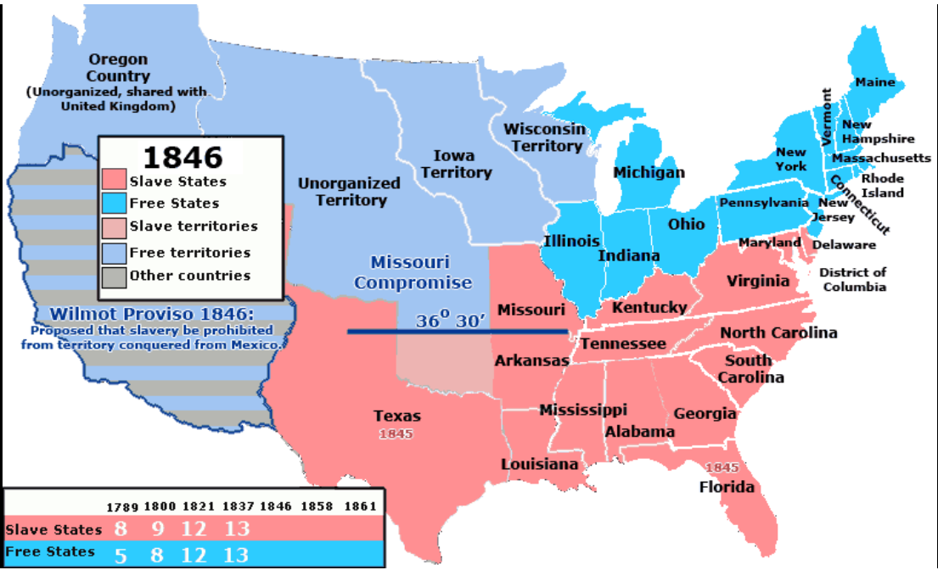
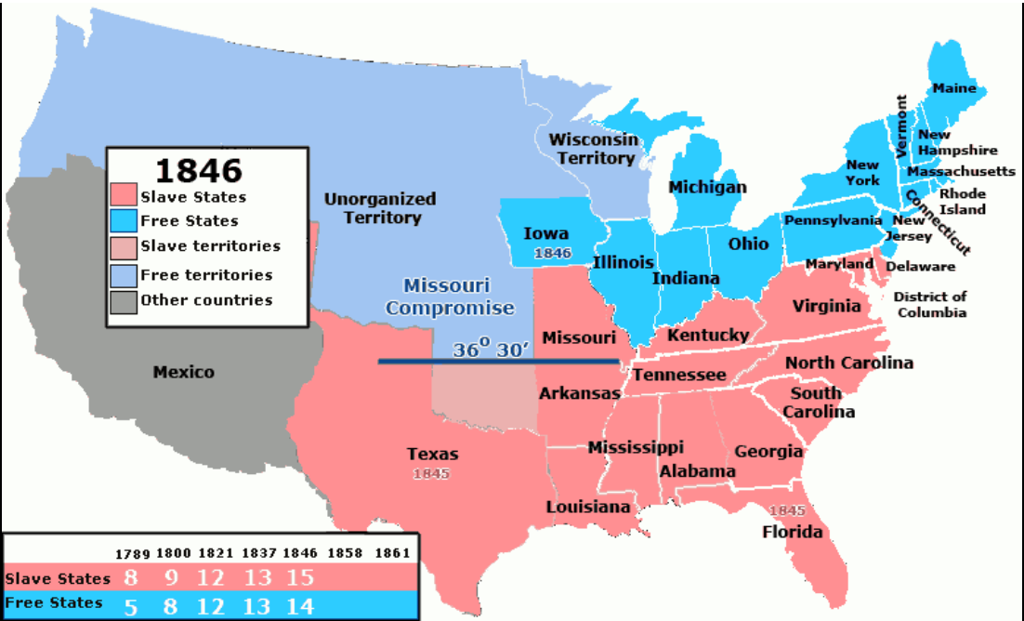

Document 3B: Abraham Lincoln, 1860
“the act of sending an armed force among the Mexicans was unnecessary, inasmuch as Mexico was in no way molesting or menacing the United States or the people thereof; and that it was unconstitutional, because the power of the levying war is vested in Congress and not in the President.”

Document 3C: “The Land of Liberty,” Punch Magazine (London), December 4, 1847

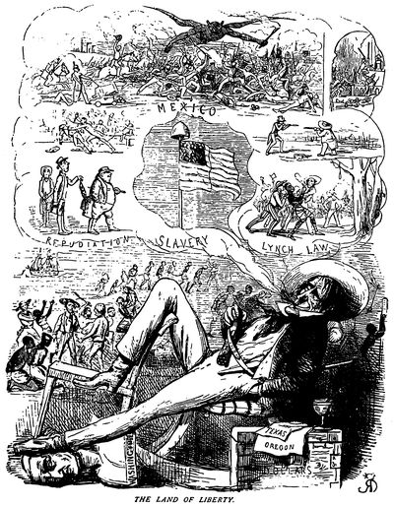This political cartoon appeared in Punch Magazine in London, criticizing the American war with Mexico.

Document 3D: Excerpt of letter by William Lloyd Garrison, 1847.

The atrocious war with Mexico...is certainly not a popular war; it was begun and is carried on against the deep moral conviction of the sober portion of the people; its real object, the extension and preservation of slavery, no intelligent man honestly doubts; still, the diabolical motto, “our country, right or wrong…

Document 3E: Zachary Taylor, letter to friend RC Wood
In this letter Taylor, a Louisiana slaveholder and future president, discusses an explosive controversy that had erupted in Congress over the Wilmot Proviso. The proviso, an amendment to a bill to fund the war, would prohibit slavery from any territory acquired from Mexico, ultimately passed the House of Representatives but was defeated in the Senate.

The Wilmot Proviso will shake [Congress] to its center... but I hope some compromise will be entered into between the two parties slavery & anti slavery which will have the effect of allying violent passions on both sides, which will have the effect of perpetuating...or shortening the Union....there will be great changes in the complexion of political affairs between now & the end of this next session of Congress; the Whigs as an antislavery and antiwar party I look upon as doomed

Document 3F: Henry Clay, Speech on the Mexican War, 1847
How did we unhappily get involved in this war? It was predicted as the consequence of the annexation of Texas to the United States. If we had not Texas, we should have no war...This is no war of defence, but one unnecessary and of offensive aggression.

We are informed by a statement which is apparently correct, that the number of our countrymen slain in this lamentable Mexican war, although it has yet been of only 18 months existence, is equal to one half of the whole of the American loss during the seven years of the Revolution! And I venture to assert that the expenditures of treasury...will be found to be more than half of the pecuniary cost of the war of our independence.

We are utterly opposed to any purpose of annexing Mexico to the United States, in any mode, and especially by conquest; that we believe the two nations could not be happily governed by one common authority, owing to their great difference of race, law, language and religion, and the vast extent of their respective territories, and large amount of their respective populations...and we oppose any desire to acquire territory for the propogation or introduction of slavery...

Document 3G: Charles Sumner Denounces the Texas Land Grab, 1847
The idea was early promulgated [promoted] that this extensive province ought to become a part of the United States. Its annexation was distinctly [supported] in the Southern and Western states in 1829; and it was urged on the ground of the strength and extension it would give to the "Slave Power," and the fresh market it would open for the sale of slaves…in seeking extension of slavery, [Americans] repudiated the great truths of American freedom....

Document 3H: South Carolina Senator John C. Calhoun, Speech before Congress, 1848
[We] have never dreamt of incorporating into our Union any but the Caucasian race, the free white race. To incorporate Mexico, would be the very first instance of incorporating an Indian race; for more than half of the Mexicans are Indians, and the other is composed chiefly of mixed tribes. I protest against such a union as that! Ours, sir, is the Government of a white race...

Are we to associate with ourselves as equals, companions, and fellow-citizens, the Indians and mixed race of Mexico? [Mr. President], I would consider such a thing fatal to our institutions….

We make a great mistake, sir, when we suppose that all people are capable of self-government. We are anxious to force free government on all...It is a great mistake. None but people advanced to a very high state of moral and intellectual improvement are capable, in a civilized state, of maintaining free government...

